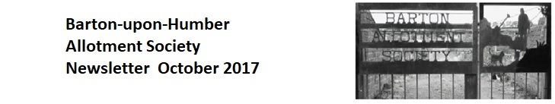
This year the Show made a profit of £255.74, slightly more plot holders took part and there were 9 more individuals (outside the Allotment Society, but most from Barton) taking part. The townspeople do seem to enjoy this annual event, and support it regularly every year. It’s an great time to share what ‘growing your own’ is all about, as well as cooking the produce, arranging the flowers or even taking photos of it all!
Next year we are hoping to introduce new categories, especially for novice Show entrants as well as the younger generations, those just starting to take an interest in gardening for pleasure. Also, we would really like to increase the cooking, baking and jam making - there are a lot of very talented cooks out there. Any ideas for a new show - we’d love to hear them? Please contact via the website, Facebook or via a committee member. Details at the end of this newsletter.
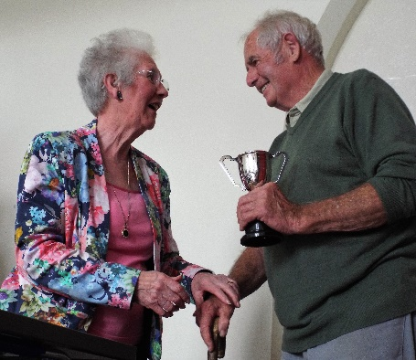  Mick Newmarch is Cookery King | 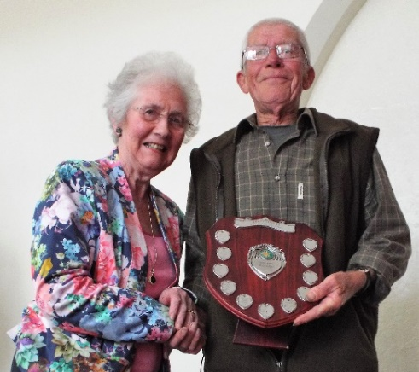  Ralph Killick for best plot 2017
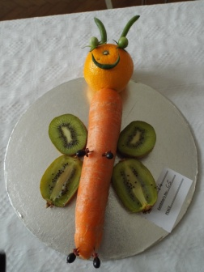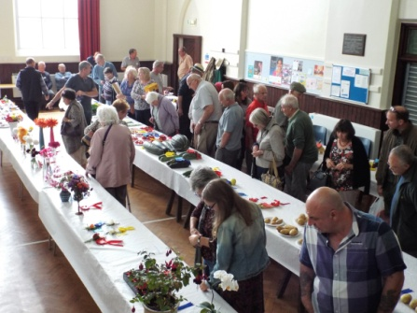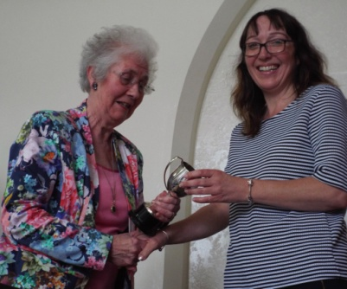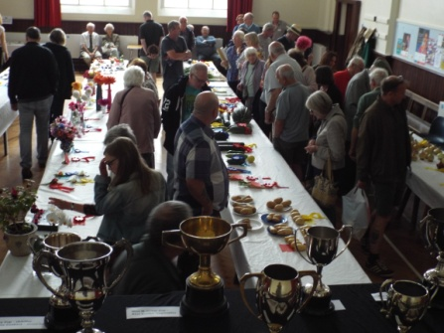
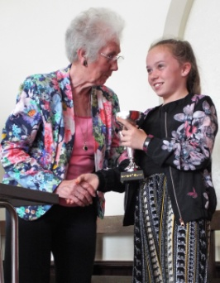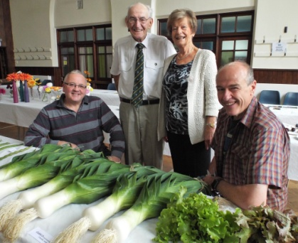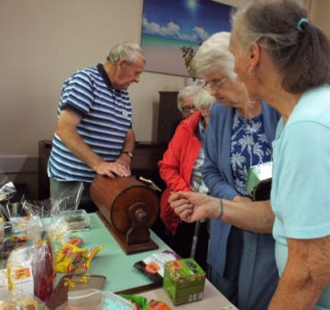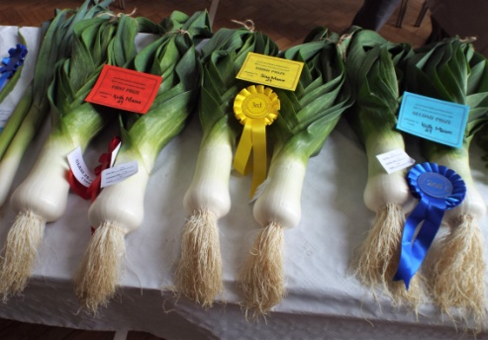

Before we finish with the Show for 2017, if anyone would like to help with organising of the 2018 Show, please don’t hesitate to say. We would welcome anyones input, no matter how little time you may have to give.
In recent years we’ve seen new plot holders start to grapple with their piece of land, and maybe, among those people, or their friends and families, there may be some with an artistic ability? Someone who could design next year's poster?!
If you’d like to ‘have a go’ - start designing now! All entries must be handed in to a committee member, or via email to: penny.thornton@live.co.uk before December 25th 2017. The winning design will be announced at the AGM in January 2018.
OUR GATE
PLOT HOLDERS WHO ORDER SEEDS FROM SUTTON SEEDS WILL BE GIVEN A 45% DISCOUNT. NON SEED ITEMS RECEIVE A 10% DISCOUNT. ON TOP OF THIS, OUR SOCIETY WILL RECEIVE A 5% BONUS ON TOTAL SALES AT THE END OF THE YEAR.
WHEN ORDERING, PLEASE ENTER THIS CODE: GS1224D
Please note that Bob has fitted a clip lock to the gate so the chain can be held back. Not everyone is using this. Please help safeguard the gate from further damage by fastening the gate back properly. Stop it swinging!
Also, the last vehicle out is not always locking the gate. This could be because they leave the plot suspecting others will arrive later, but we must each make sure we LOCK the gates if no one if left inside. We all have the code to open the gates.
Stop the rabbits as well as potential intruders.
(Oh, and by the way – it’s been suggested we ask a tattooist to attend the AGM, so anyone wanting the new gate code inking onto their body, can do. To date, the idea doesn’t have a seconder. LOL)

Up and coming events:
How about a pre-Christmas Pub Quiz?
We have been contacted by the Volunteer Arms pub in Barton with a proposal to hold a Barton-Allotment Christmas quiz evening...reports are that the food is delicious and excellent value and...a welcoming drink to focus on a quiz. What could be better? More details to follow as soon as we have them.
Members are also advised about next year's Barton open gardens event - this will be held on 30th June and 1st July next year. We plan to open the allotments up for viewing on one of those days...more details later.
Next year's horticultural show...this will be held on Saturday 18th August 2018. More details to follow as we get them.
The AGM of Barton Allotment Society will take place on Tuesday 9th January...venue and further details to follow.
Follow us on Facebook and the website http://barton-upon-humber-allotment-society.com/index.html - we'll try to keep as up-to-date as possible

...and a few more pictures from the show
